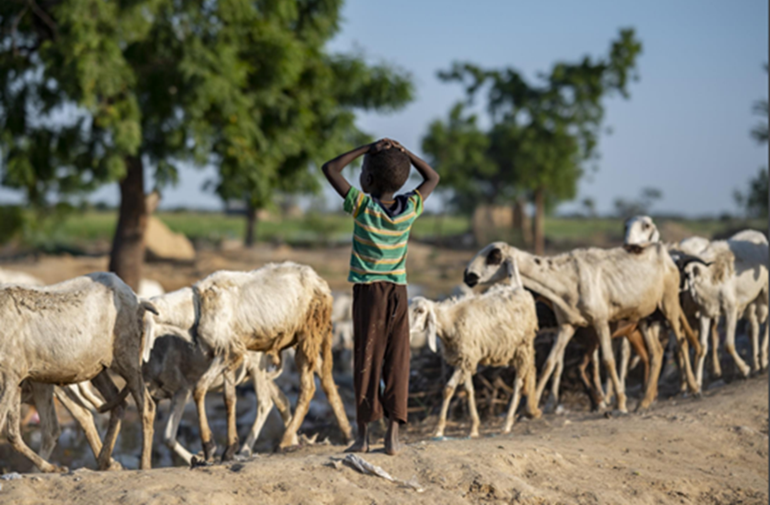
© UNHCR / name of the photographer

Protection Analysis Update
Photo Credit

BRIEF
REPUBLIC OF SORAMI
Protection Analysis Update | December 2022

Text: max. ½ page
A fourth consecutive failed rainy season has pushed parts of the Republic of Sorami – ROS – to the brink of famine. Throughout 2022, severe drought, conflict, climatic shocks, and forced evictions have had a cumulatively devastating effect on the population’s coping capacities and vulnerabilities, which is escalating the impact of existing protection risks. Since January 2022, recent conflicts in N’gurtu, Solbei, Tissura, Ateppo, Piru and other areas, coupled with unprecedented flooding in Solbei, Tissura and Piru, have only served to reverse many of the gains made through humanitarian assistance provided in 2021-22. The situation requires an upscaling of efforts to avoid catastrophic consequence in the 1st quarter of 2023.
The protection risks requiring immediate attention in the period covered by this analysis are:
- Attacks on civilians and other unlawful killings
- Siege and unlawful impediments to movements
- Conflict-related gender and intimate partner violence
- Forced evictions of IDP gatherings
- Serious maiming and injuries due to explosive hazards

URGENT ACTION NEEDED
Urgent action is needed to stop the emerging negative coping strategies, driven by the increased food insecurity, conflict, tensions for natural resources and the unprecedented rising of abuse and exploitation that have been identified.
It is of utmost importance to:
- Ensure the timely provision of humanitarian assistance by amending the impediments caused by Law 6/42 of January 2022, and allow UNAMS dialogue and coordination for the safe passage of convoys.
- Draft a joint inter-sectoral emergency response specifically targeted to strengthen the tijen, through community-based interventions, deployment of negotiation officers and multi-purpose cash support.
Text: max. 2 paragraphs

CIVILIAN CASUALTIES |  | GBV INCIDENTS |  | IDP DROUGHTS |  | IDP CONFLICT |  | FORCED EVICTIONS
1,359 |  | 1,429 |  | 757,000 |  | 976,000 |  | 81,461
% PERIOD | % YEAR | % PERIOD | % YEAR | % PERIOD | % YEAR | % PERIOD | % YEAR | % PERIOD | % YEAR
+18% | +65% | +20% | +50% | +18% | -8% | +28% | +45% | +33% | +21%

Since June 2022, security and the state of protection have progressively deteriorated, due to the intensification of conflict by local armed groups. The proclamation of Law 6/42 in January 2022, which bestowed all control and oversight on budgets on the recently created Minister of Departmental Affairs, removing functions previously under the Governors of each department, has exacerbated the tensions and increased the number of armed attacks.
The curfew imposed between September and October 2022 by the Popular Front (PF) currently in power has further worsened the situation. Since January 2022, Sorami has been characterized by an active armed conflict across all its territory.

Text: max. 2 pages

RISK 1 | Attacks on civilians and other unlawful killings

CONCERNING TRENDS
The areas more at risk include rural villages in the areas of Ateppo, Tissura, Upper Syle and Lombardy, as well as the IDP sites in the areas of N’gurtu, Piru, South Salla and Solbei, particularly those closest to areas controlled by the Popular Front of Southern Sorami (PFSS) and the operational commands of governmental authorities.
Armed violence skyrocketed following the government’s decision to approve Law 6/42 in January 2022, which provides central control over departmental budget and funding, in an attempt to hamper the ethnic federalism created in 1992 to put at an end to the Sorami Civil War. As a result, the civilian population, which also comprises 345,581 IDPs, has been forced to move to escape attacks and due to the general insecurity.
MOST SERIOUS IMPACTS
According to the Sorami National Police (SNP), between June and December 2022, at least 2,344 people were killed, injured or kidnapped as a result of armed violence, which has included armed attacks, air and drone strikes, shelling, missile attacks and conflict-related sexual violence. The aggressions represent an increase of 18% compared to the 1,923 cases registered between January and June 2022. Men comprise the majority of victims (86% or 2,016 individuals), followed by women (10% or 234 individuals) and children as young as 5 years old (4% or 94 individuals). The monitoring mechanism of the Ministry of Health and WHO has registered 65 attacks on health facilities, compared to 34 in the previous quarter.

RISK 2 | Siege and unlawful impediments to movements

RISK 3 | Conflict-related gender and intimate partner violence

RISK 4 | Forced evictions of IDP gatherings

RISK 5 | Serious maiming and injuries due to explosive hazards

Text: max. ½ page

PROGRESS MADE ON PROTECTION
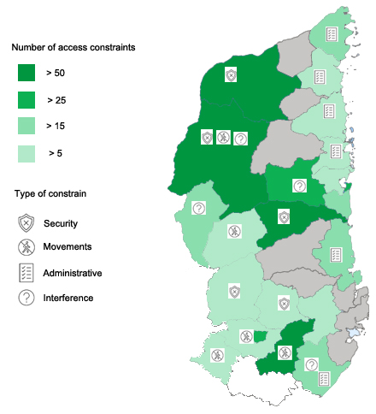
As of February 2022, 32 protection partners are responding to the protection needs of over 3 million people in need. Approximately 250,000 people were reached in January and February 2022. 79% of persons reached are from Tissura and Piru and mainly in the major towns of Arum, Mailo, Sarwa and Sakelle, hosted in IDP sites. 80% of protection services were in GBV prevention and risk mitigation, awareness raising and MHPSS.
In December 2021, the first humanitarian explosive ordnance intervention in RSPT-controlled areas was launched as part of the HCT-coordinated response, following years of extensive negotiations. A new mine action INGO was also registered in Arum, expanding the capacities for mine action survey and clearance. The mine action response however remains critically underfunded.
ACCESS RELATED CHALLENGES AND ACTIONS
Safety and security remain a priority concern, both at the gathering points and in areas of previous residence in Manura and Solbei. The absence of effective political efforts to address inter-communal conflicts, especially between the Runis and the Alemi, leaves the population in constant fear and insecurity, particularly in Railey, Sonrli, Upper Syle and Lombardy.

Text: max. 1 page

RISK 1 | Attacks on civilians and other unlawful killings
GOVERNMENT and PARTIES TO THE CONFLICT
- Stop the use of EWIPA, in line with commitments under the political declaration on EWIPA, and support the completion of a national mine action survey to capture the extent of contamination and provide information on any known contamination in the 1st and 2nd quarters of 2023.
HC and HUMANITARIAN COMMUNITY
- The erosion of livelihood and purchasing power by the population must be met with multi-sectoral initiatives to mitigate economic impacts on the population, including persons with disabilities, children, and women, to avoid a worrying increase in children abuse and exploitation and trafficking in Railey, Sonrli and Upper Syle during the 2nd quarter of 2023.
RISK 2 | Siege and unlawful impediments to movements
DONORS
- Ensure all NGOs have access to the Humanitarian Exchange Facility and Humanitarian Financial Corridors, ensuring low transfer costs and securing insurance to reduce the liability of NGOs for dealing with cash by the 2nd quarter of 2023.
RISK 3 | Conflict-related gender and intimate partner violence
PROTECTION SECTOR and PARTNERS
- Ensure that, in 2022, Child Safeguarding Policy training has been systematically provided for all humanitarian workers and communities to ensuring that all humanitarian actions are properly implemented to protect all children from the increasing deliberate or unintentional acts of abuse and exploitation registered in the last quarter.
RISK 4 | Forced evictions of IDP gatherings

RISK 5 | Serious maiming and injuries due to explosive hazards

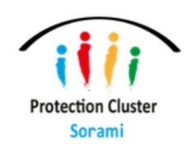
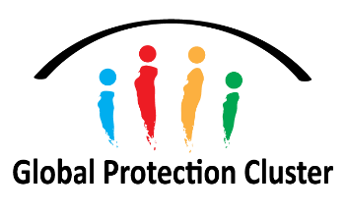
Endnotes
Methodology
The analysis has been based on both quantitative and qualitative data from existing secondary data sources, protection assessments and reports covering events from April to December 2022, including data from key country-wide protection monitoring tools – the Sorami Protection Monitoring System (SPMS), Protection and Return Monitoring Network (PRMN) and the eviction Information Portal.
Limitations
Data available in Sorami is predominantly limited to areas that are currently accessible by humanitarian actors. Areas in Tissura, Central Syle, Rusa, and Piru, as well as areas in Manura under CNU control, are currently inaccessible to the humanitarian community. Expert judgement and a series of reflection exercises with the UNAMS and the NSCHN have been carried out for the identification of protection risks and their severity in those areas.

For further information please contact: Nur Haddad - nhaddad@unhcr.org | Giulia Piro – g.piro@prc.org

HC statement on implementation of Law 6/42, March 2022.

